**AWS Project: Visualize Data with Amazon QuickSight**

**Project Overview**

In this mini project, I used two AWS services: Amazon S3 and Amazon QuickSight.

I also had a dataset provided by Bright Data, which consisted of 50,000 best-selling products on Amazon.com.

My goal was to store the dataset in an Amazon S3 bucket and then connect it with Amazon QuickSight to create interesting visualizations.

**Steps for the project**

**Step 1:** **Downloaded and Stored the Dataset in Amazon S3**

* I went to **AWS Management Console** and searched for "S3".
* I clicked on "**Create bucket**" to create a new bucket. I named it "soumya-amazon-project" (or any name I preferred).
* I kept the rest of the settings as default and selected "Create".
* Then, I clicked on the newly created bucket and uploaded my CSV file (Amazon bestseller dataset).
* Additionally, I uploaded the "manifest.json" file. I opened the file and replaced the bucket name with my own bucket name.
* I confirmed that both files were uploaded to the bucket.

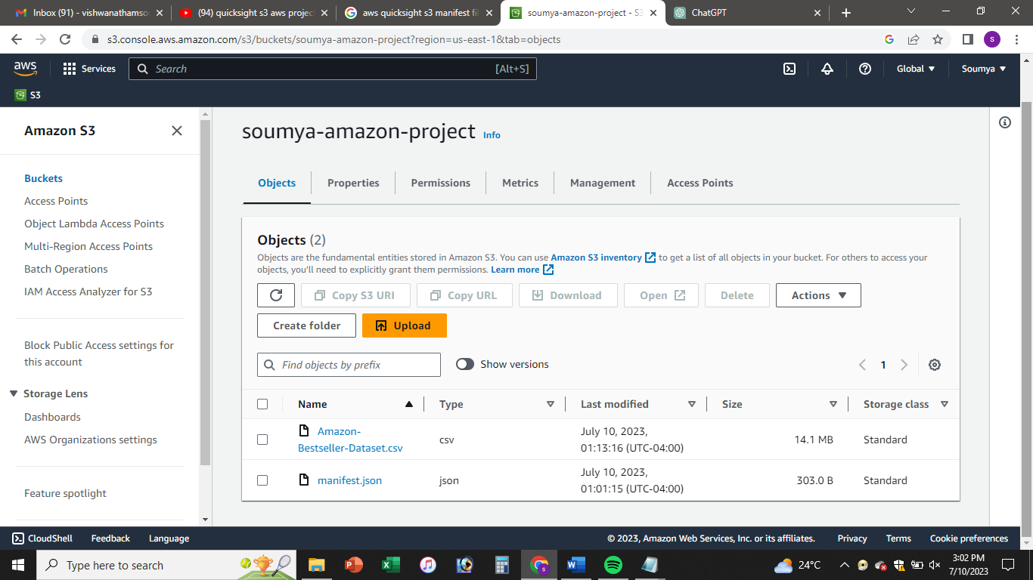

**Step 2: Set Up Amazon QuickSight**

* I opened a new tab and searched for "**QuickSigh**t" in the AWS Management Console.
* Since I didn't have a QuickSight account, I signed up for a free trial of the Enterprise Edition.
* I entered my preferred account name and email address. Then, I selected the S3 bucket I wanted to link to QuickSight and clicked "Finish".
* I waited for a few minutes while my QuickSight account was created.
* Once it was ready, I clicked on "Go to Amazon QuickSight" to access the QuickSight interface.

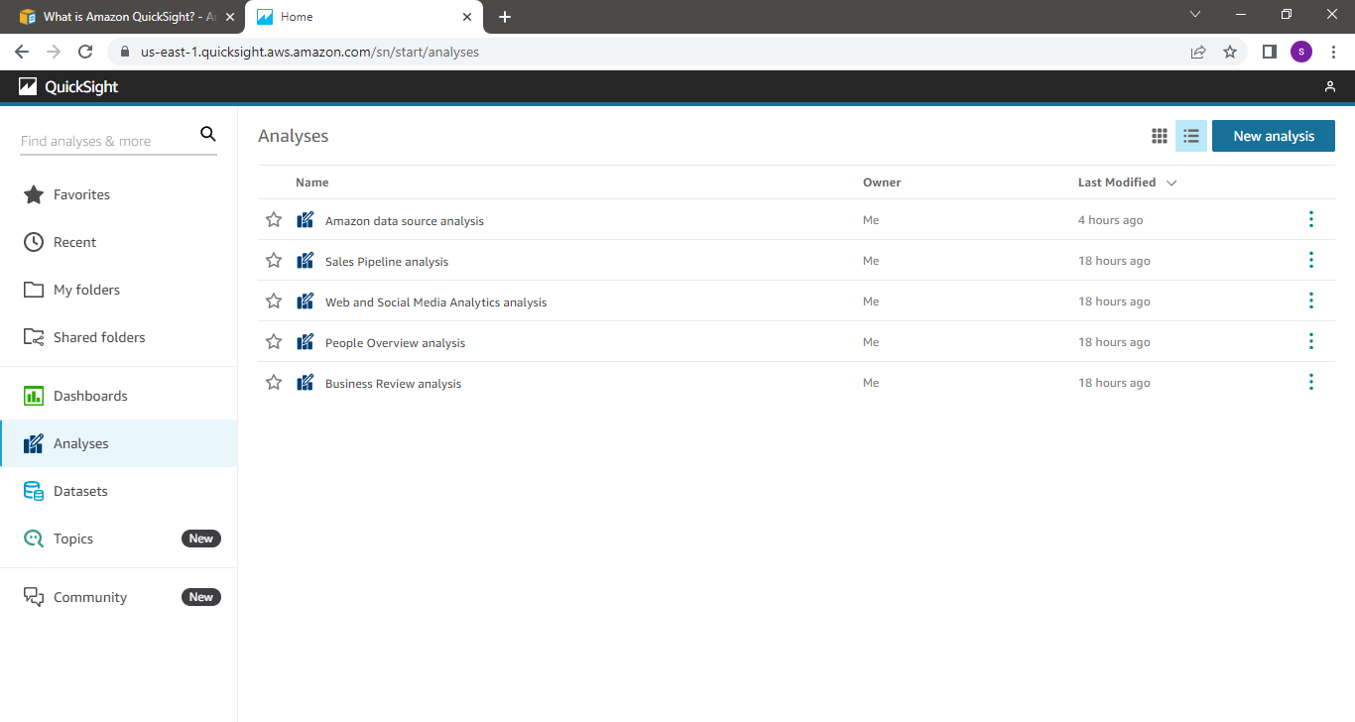

**Step 3: Imported the Dataset into QuickSight**

* In the QuickSight interface, I clicked on "Datasets".
* Then, I clicked on "New dataset" and selected "S3".
* I switched to the S3 tab and copied the URL of the "manifest.json" object.
* After going back to QuickSight, I pasted the URL in the appropriate field and provided a name for the data source (e.g., "Amazon data source").
* I clicked "Connect" and then "Visualize".
* I selected the "Interactive sheet" option and waited for the dataset to finish importing.

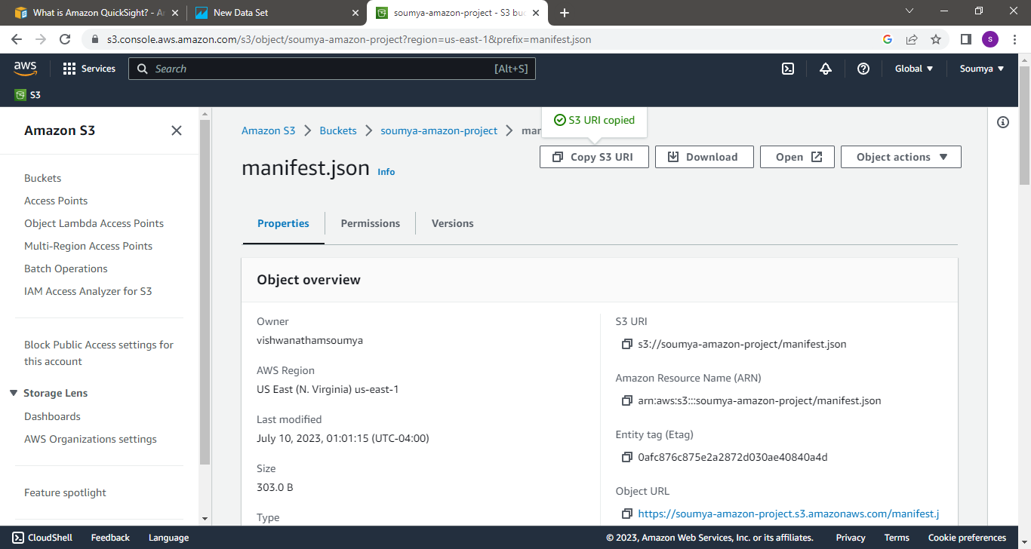

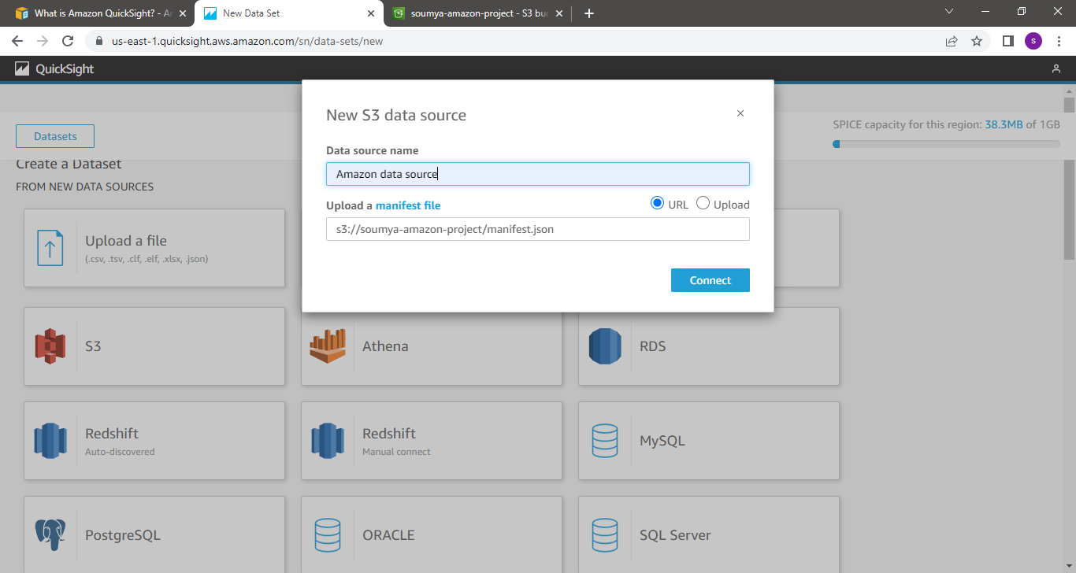

**Step 4: Created Visualizations in QuickSight**

* I named the sheet as "Most Popular Brands".
* I dragged the "brand" field into the graph to see the frequency of each brand in the dataset.
* Then, I clicked on the "brand" field, went to "Sort options", sorted by "brand" in descending order, and applied the changes.
* QuickSight displayed the most popular brands based on the dataset.
* I explored other fields and combinations to create different visualizations, such as comparing prices, analyzing top-selling product titles, or identifying sellers with the most products.

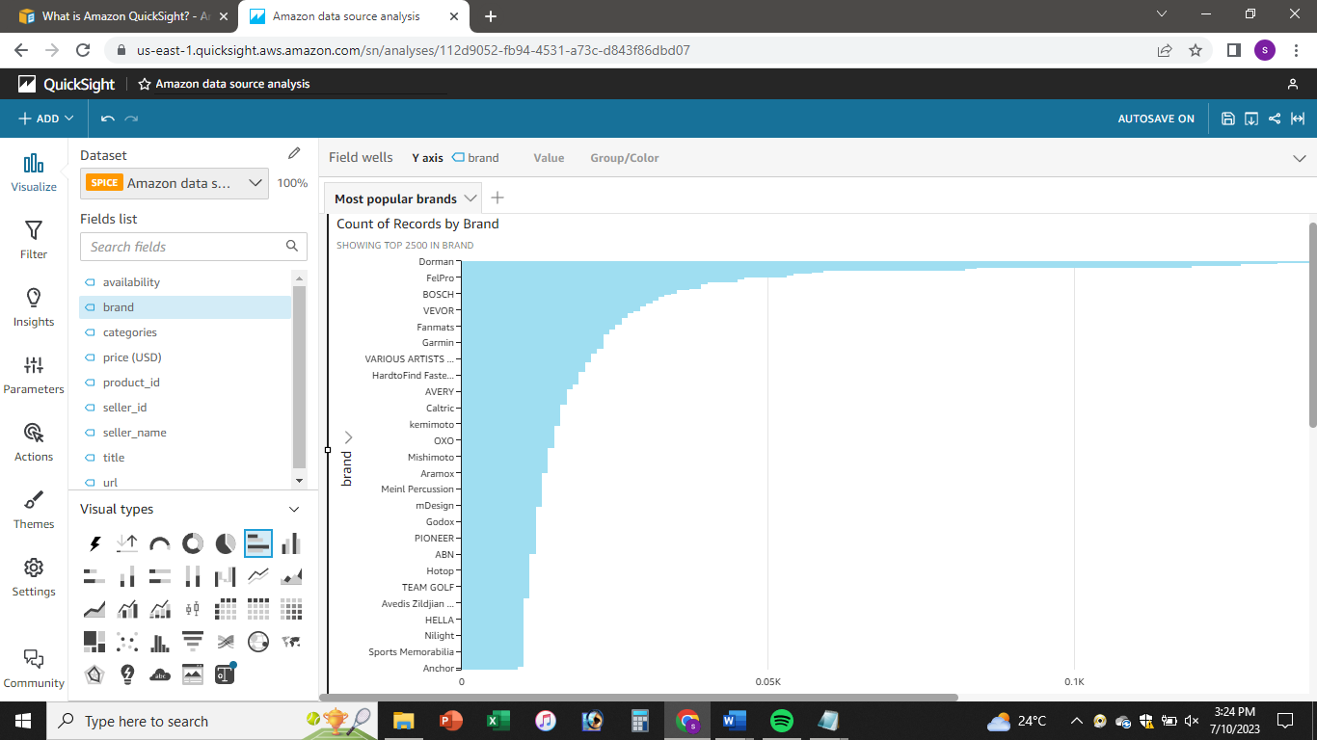

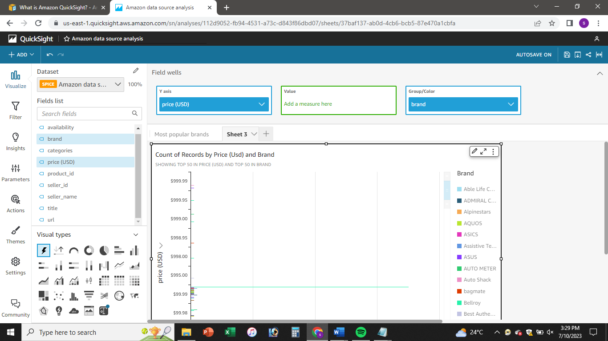

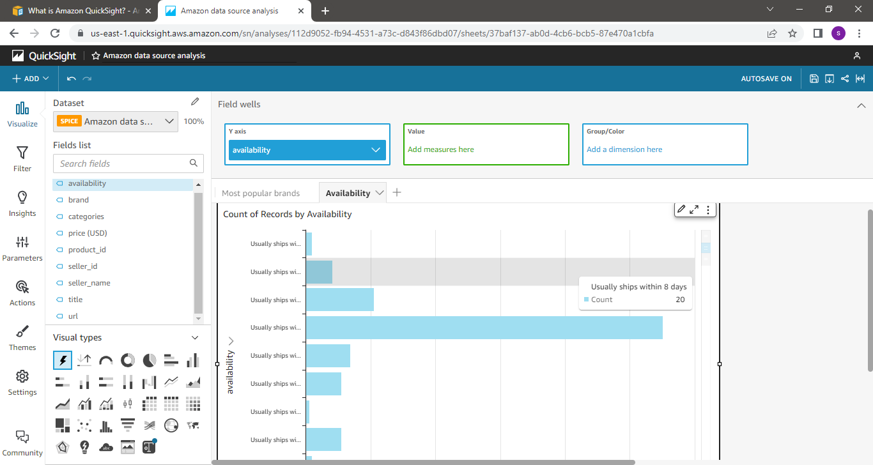

In summary, I have downloaded a large dataset, uploaded it to Amazon S3, and created a visualization dashboard using Amazon QuickSight. QuickSight offered various graph types, including bar charts, donut charts, pie charts, and word clouds. I experimented and got creative with my visualizations.